Name: ____________________________ Score: __________________

**Part A – Multiple Choice**

1. Which of the following is NOT a feature of prokaryotic cells?

A) Nucleus

B) Ribosomes

C) Cell membrane

D) DNA

2. What is the function of a mitochondrion in a eukaryotic cell?

A) Protein synthesis

B) Energy production

C) Storage of genetic information

D) Waste elimination

3. The structure responsible for maintaining cell shape and providing support in plant cells is the:

A) Chloroplast

B) Vacuole

C) Cell wall

D) Golgi apparatus

4. The resolution of a microscope refers to its ability to:

A) Magnify the specimen

B) Focus the image

C) Distinguish between two separate points

D) Illuminate the specimen

5. Which part of a microscope holds the objective lenses and rotates to change magnification?

A) Stage

B) Arm

C) Nosepiece

D) Base

6. Which statement about cell theory is correct?

A) Cells are only found in plants, not in animals.

B) All living organisms are composed of cells.

C) Cells are made up of non-living material.

D) Cells do not reproduce.

7. What is the function of a vacuole in a plant cell?

A) To store water and maintain pressure

B) To synthesize proteins

C) To produce energy

D) To transport materials within the cell

8. Which structure is found in both plant and animal cells?

A) Chloroplast

B) Cell wall

C) Mitochondria

D) Lysosomes

9. Which organelle is responsible for photosynthesis in plant cells?

A) Mitochondrion

B) Ribosome

C) Chloroplast

D) Lysosome

11. Where is the genetic material (DNA) found in a prokaryotic cell?

A) Nucleus

B) Ribosomes

C) Nucleoid region

D) Golgi apparatus

12. Which organelle is absent in prokaryotic cells compared to eukaryotic cells?

A) Ribosomes

B) Cell membrane

C) Mitochondria

D) Golgi apparatus

**Part B – Microscopes and Cells.** **[Total 24 marks]**

You will have 25 minutes to answer the following questions about microscopes and cells.

1. What is the function of a light microscope? (1 mark)

_____________________________________________________________________

_____________________________________________________________________

1. Circle the correct ending for each statement: (5 marks)
2. A cell that has a nucleus and membrane bound organelles is

EUKARYOTIC PROKARYOTIC MULTIKARYOTIC

1. When an organism is made of many cells it is

UNICELLULAR MULTICELLULAR PROCELLULAR

1. A cell containing chloroplasts is a(n)

PLANT CELL ANIMAL CELL BACTERIAL CELL

1. The G in MRS GREN stands for

GREEN GROWTH GO TO THE TOILET

e) Photosynthesis occurs in the

RIBOSOME MITOCHONDRIA CHLOROPLAST

1. Label the parts of the microscope below: (5 marks)

Focusing Screw



Base

1. The following questions are about the cell below:

3

1

1

1

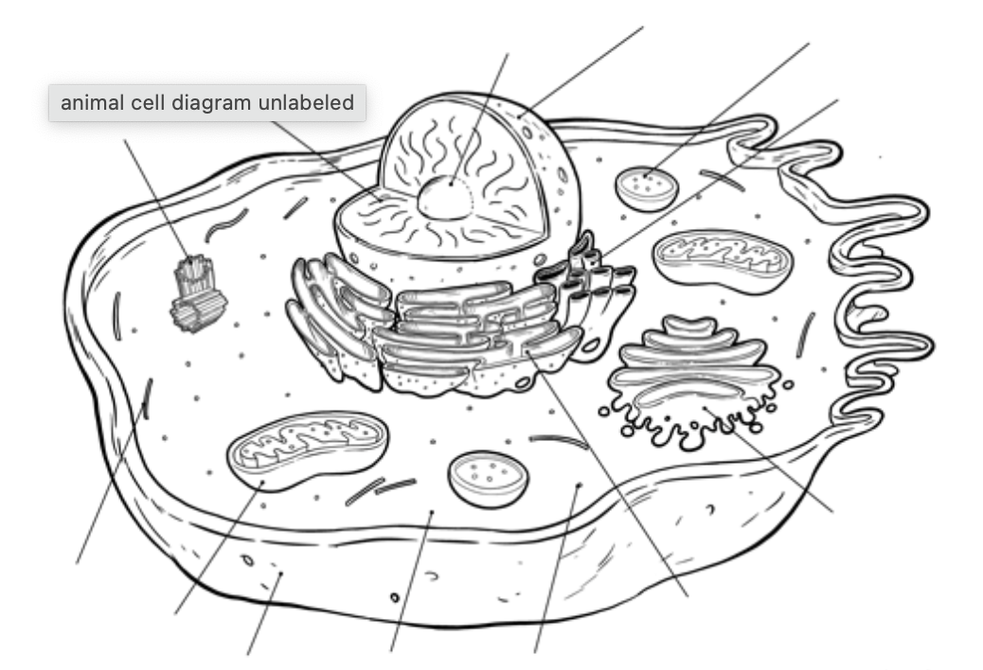

1

10

902{+

11

8

6

5

44

2

1. What is the name of organelle 1 ? (1 mark)

_______________________________

1. Draw a cross on the nucleus. (1 mark)
2. What is the function of the ribosome? (1 mark)

_________________________________________________________________

1. What is the function of organelle 6? (1 mark)

_________________________________________________________________

1. Is this cell a plant or an animal cell? How do you know? (2 marks)

____________________________________________________________________

____________________________________________________________________

____________________________________________________________________

f) If organelle 4 suddenly disappeared what would be the effect on the cell? (2 marks)

____________________________________________________________________

____________________________________________________________________

____________________________________________________________________

**End of Part B**